\

School of Social Sciences

Economics

C29PE

Economics for professionals

SOLUTIONS

August Examination and Assessment Diet 2024-2025

Duration: 2 Hours

Section A: Multiple Choice Questions (30 Marks)

There are 20 questions in this section. Please answer all questions at the start of your answer paper. Each question is worth 1.5 marks.

Answer key:

1 | A | 6 | D | 11 | C | 16 | C
2 | C | 7 | B | 12 | B | 17 | D
3 | C | 8 | B | 13 | A | 18 | A
4 | D | 9 | B | 14 | D | 19 | A
5 | A | 10 | C | 15 | B | 20 | B

Question 1
After the pandemic, there was an increase in the demand for new cars. However, supply chain issues created a shortage of some of the components required in the production of cars.
According to economic theory, the above scenario would lead to:
A. A rightwards shift in the demand curve, a leftward shift in the supply curve and an increase in the price of new cars.
B. A leftwards shift in both the demand curve and the supply curve, and an increase in the price of news cars.
C. A rightwards shift in both the demand curve and the supply curve, and a fall in the price of new cars.
D. A rightwards shift in the demand curve, a leftward shift in the supply curve, and no change in the price of new cars.
Answer: A

Question 2
During a 15 year career as an accountant, Nina estimates that she has spent more than $75,000 on education and training opportunities. She is now thinking of retraining to become a life coach. In making her choice, Nina should consider:
A. The investments which she has already made in becoming an accountant
B. The sunk cost of becoming an accountant and the costs of making the career change.
C. The benefits from the career change, and the costs of making it.
D. The opportunity cost of becoming a life coach and the value of her investment in becoming an accountant.
Answer: C

Question 3
The marginal cost of a litre of milk in the supermarket is $0.50 per litre, but it sells for $1.25 per litre. Philip is willing to pay $2.15 per litre of milk. From this, we can conclude that:
A. The supermarket faces a perfectly competitive market.
B. Philip enjoys a consumer surplus of $2.15 per litre of milk.
C. The supermarket enjoys a producer surplus of $0.75 per litre of milk.
D. Philip enjoys a consumer surplus of $1.75 per litre of milk.
Answer: C

Question 4
In response to weakening demand for places, a private school reduced its junior school prices from $17,000 per pupil per year to $14,000 per pupil per year. As a result of the price reduction, it was observed that pupil numbers in the junior school increased from 300 to 400. Using the mid-point formula, we can conclude that:
A. Demand is price inelastic, with elasticity approximately equal to -0.6.
B. Demand is price elastic, with elasticity approximately equal to -3.2.
C. Demand is price inelastic, with elasticity approximately equal to 0.5.
D. Demand is price elastic, with elasticity approximately equal to -1.5.
Answer: D

Question 5
Two cinema chains, CineA and CineB, are in a price war. If CineA cuts its ticket prices by 15%, and the cross-price elasticity of demand is -2, then
A. CineB will suffer a 30 per cent reduction in ticket sales.
B. CineB will suffer a 50 per cent reduction in ticket sales.
C. CineA will see ticket sales increase by 15%.
D. CineA will see ticket sales increase by 25%.
Answer: A
Question 6
The government seeks to stabilise rents in the private rented sector by imposing a rent ceiling. If the rent ceiling is set above the current market price, we would expect the rent ceiling to:
A. Lead to excess supply.
B. Increase the quantity of rental properties demanded in the private residential sector.
C. Decrease the supply of private rental properties.
D. Have no effect on the market.
Answer: D

Question 7
Large tech firms, like Apple or Samsung, benefit from economies of scale. The concept of economies of scale can be applied to:
A. Short-run analysis and will relate to the increasing productivity of variable factors, such as labour, as a result of improved working practices and training.
B. Long-run analysis, since tech firms can then vary the use of all factors of production freely.
C. Short run analysis and will relate to the adoption of increasingly productive technology.
D. The analysis of externalities, reflecting the adoption of technologies which reduce carbon emissions.
Answer: B

Question 8
Mary’s Quality Berries is a price-taking firm. Following a sudden increase in market demand, in the short run, we will expect that the firm will:
A. Continue to charge the same price as before the increase in demand and sell more output.
B. Continue to apply marginal cost pricing, but charge the higher market price, determined by supply and demand conditions.
C. Raise the price of the firm’s berries above the new market price, to increase profits.
D. Increase advertising, to differentiate the firm from its competitors, increasing market power.
Answer: B

Question 9
In developing a production plan, which of the following will be a consideration for a vehicle leasing firm.
A. In the short run, it cannot vary the working hours of its employees.
B. In the short run, there will be at least one factor of production which is fixed.
C. In the long run, it will be able to employ additional workers but not purchase new vehicles.
D. In the long run, it will be able to increase profits if its doubles all factors of production.
Answer: B

Question 10
Which of the following is the best example of a negative externality in consumption?
A. The illumination produced by streetlights.
B. Environmental pollution produced during a firm’s production process.
C. Loud music played in an apartment building late at night.
D. Free riding by downloading music illegally.
Answer: C

Question 11
When incomes rise, imports tend to
A. Stay the same
B. Fall
C. Rise
D. Behave in an unpredictable manner.
Answer: C

Question 12
Here is a simple model of a closed economy
Consumption: C = 500 + 0.75Yd
Disposable income: Yd = Y - T
Investment: I = 1,000
Government spending: G = 1,500
Tax: T = 0.2Y
The equilibrium income of the economy is
A. 5,000
B. 7,500
C. 10,000
D. 12,500
Answer: B

Question 13
Which of the following would cause GDP to fall?
A. An increase in savings, which is not matched by an increase in government expenditure.
B. An increase in foreign investment which is not matched by an increase in exports.
C. An increase in exports, which is not matched by an increase in imports.
D. An increase in government spending, without any increase in taxation.
Answer: A

Question 14
According to the Quantity Theory of Money, the value of payments in money in a year equals nominal GDP. It follows that in a country with a monetary stock M = 5,000, a price level P = 1.5, and real GDP, Y = 3,000, the velocity of circulation (V) is:
A. 1.50
B. 0.67
C. 0.83
D. 0.90
Answer: D

Question 15
Given that the liquidity ratio of the banking system is 25%, if businesses deposit an additional $200m, then we expect that a further
A. $1,000m worth of new deposits will be created.
B. $600m worth of new deposits will be created.
C. $200m worth of new deposits will be created.
D. $50m worth of new deposits will be created.
Answer: B

Question 16
The use of expansionary monetary policy to increase aggregate demand is likely to lead to:
A. Higher interest rates, and a weakening of the domestic currency.
B. Higher interest rates, and a strengthening of the domestic currency.
C. Lower interest rates, and a weakening of the domestic currency.
D. Lower interest rates, and a strengthening of the domestic currency.
Answer: C

Question 17
As a result of supply chain disruption and soaring energy and fuel prices, many countries around the world experienced cost-push inflation. What would we expect to observe in this scenario, ceteris paribus?
A. A rightwards shift in the AS curve, an increase in the price level and a rise in national income.
B. A leftwards shift in the AD curve, an increase in the price level and a fall in national income.
C. A leftwards shift in the AS curve, an increase in the price level and an increase in national income.
D. A leftwards shift in the AS curve, an increase in the price level and a fall in national income.
Answer: D

Question 18
A recession brought about by rising geopolitical tensions and surging financial stress will be associated with an increase in which form of unemployment in the short run?
A. Cyclical unemployment
B. Structural unemployment
C. Real wage unemployment
D. Frictional unemployment
Answer: A

Question 19
Which of the following constitutes a market-oriented supply-side policy?
A. Policies to encourage competition.
B. Improvements in infrastructure, such as a better transport system.
C. Government funded spending on research and development.
D. Government funded training schemes.
Answer: A

Question 20
Suppose that there are only 2 countries in the world, namely Country A and Country B. Each country produces only two goods – rice and tomatoes. Country A employs 500,000 workers, while Country B employs 250,000 workers. The table below shows the production of each good using one worker:

 | Country
Goods | Country A | Country B
Rice (tonnes) | 4 | 6
Tomatoes (tonnes) | 10 | 12

Which statement below is true?
A. Country B has a comparative advantage in both goods.
B. Country B has a comparative advantage in production of rice and Country A has a comparative advantage in production of tomatoes.
C. Country A has a comparative advantage in production of rice and Country B has a comparative advantage in production of tomatoes.
D. Both Country A and Country B have absolute advantages in the production of one good.
Answer: B

(Total: 30 marks)

Section B: Short Answer Questions (40 marks)

There are four questions in this section, each worth 10 marks. You should answer all questions.

Question 1

Research suggests that 2023 was a difficult year for electric car manufacturers as millions of consumers delayed purchasing a new vehicle purchase due to growing economic uncertainty. However, there are several factors that may be able to increase market demand for electric vehicles (EV).

- Describe three factors that could shift the demand curve for EVs to the right and help to increase demand for EVs in the next 1 to 5 years.
(3 marks)
Answer: 1. The rising availability of charging stations and the ease and cost of using them. 2. Increases in income as higher-income households may be more likely to purchase EVs. 3. Government incentives, such as tax credits or rebates. 4. Environmental concerns – if consumers are more environmentally conscious, they may be more willing to purchase EVs. 5. Improvements in the range that EVs can do. 6. Increases in the price of diesel or petrol.

- In early 2023, Tesla (a leading manufacturer of EVs) cut the price of some of its most popular electric cars by thousands of dollars in Europe and the US, in a bid to boost customer demand.

- Explain why the concept of price elasticity of demand can help Tesla to determine the extent to which demand will increase as a result of its price cuts.

- If all other things remain equal, will the price cuts increase Tesla’s total revenue from EV sales?

- Describe two factors that could impact the price elasticity of demand for Tesla EVs.
(3 marks)
Answer: (i) Price elasticity of demand (PED) is a measure of how much the quantity demanded of a good or service changes in response to a change in its price. It quantifies the responsiveness of consumers to price changes. In the context of Tesla, PED helps determine how sensitive customers are to price changes of EVs. (ii) If PED is elastic, TR will increase in response to the price reductions. If PED is inelastic, TR will fall in response to the price reductions. (iii) The number of substitutes – more car manufacturers are starting to offer EVs. The proportion of income spent on the product – EV purchases are likely to require a large proportion of income to be spent. The degree of necessity – cars may be a necessity for some, but EVs tend to be seen as luxury items.

- Draw a diagram to illustrate what might happen if the UK government decided to impose a maximum price on EVs sold in the UK (without providing any subsidies or other funding to EV manufacturers), to encourage both consumers and businesses to purchase EVs. Assume the price ceiling is set at 10% below the current market price.
(4 marks)
Answer: The diagram should have price of EVs on the y-axis, and quantity of EVs on the x-axis. There should be a downward sloping demand curve and an upward sloping supply curve. The equilibrium/market price should be shown at the intersection of the demand and supply curve. The price ceiling should be a horizontal line that sits below the equilibrium price. The diagram or description needs to show a higher level of demand, and a lower level of supply compared to the equilibrium price leading to a shortage of EVs. A price ceiling will also cause consumer surplus to increase.
(Total: 10 marks)

Question 2

In the market for children's cupcakes, a small producer can hire up to 10 staff, paying a wage of 12.50 per hour, with a fixed cost of 50.00 attributable per hour of work. It can sell its cupcakes at a price of 3.00.

Workers | 1 |  | 2 |  | 3 |  | 4 |  | 5 |  | 6 |  | 7 |  | 8 |  | 9 |  | 10
Quantity of  cupcakes produced | 6 |  | 16 |  | 30 |  | 48 |  | 64 |  | 78 |  | 90 |  | 100 |  | 108 |  | 112
TVC
TFC
AVC
AFC
AC
MC
In the table, the abbreviations in the row headings represent:
TVC: total variable cost; TFC: total fixed cost; AVC: average variable cost
AFC: average fixed cost; AC: average cost; MC: marginal cost

- Complete the table showing the hourly costs faced by the firm. (Reproduce the table in your answer booklet and fill up the blanks.)
(5 marks)
Answer:
Workers | 1 |  | 2 |  | 3 |  | 4 |  | 5 |  | 6 |  | 7 |  | 8 |  | 9 |  | 10
Quantity of cupcakes produced | 6 |  | 16 |  | 30 |  | 48 |  | 64 |  | 78 |  | 90 |  | 100 |  | 108 |  | 112
TVC | 12.5 |  | 25.0 |  | 37.5 |  | 50.0 |  | 62.5 |  | 75.0 |  | 87.5 |  | 100.0 |  | 112.5 |  | 125.0
TFC | 50.0 |  | 50.0 |  | 50.0 |  | 50.0 |  | 50.0 |  | 50.0 |  | 50.0 |  | 50.0 |  | 50.0 |  | 50.0
AVC | 2.08 |  | 1.56 |  | 1.25 |  | 1.04 |  | 0.97 |  | 0.96 |  | 0.97 |  | 1.00 |  | 1.04 |  | 1.12
AFC | 8.33 |  | 3.13 |  | 1.67 |  | 1.04 |  | 0.78 |  | 0.64 |  | 0.56 |  | 0.5 |  | 0.46 |  | 0.45
AC | 10.41 |  | 4.69 |  | 2.92 |  | 2.08 |  | 1.75 |  | 1.60 |  | 1.53 |  | 1.50 |  | 1.50 |  | 1.57
MC |  | 1.25 |  | 0.89 |  | 0.69 |  | 0.78 |  | 0.89 |  | 1.04 |  | 1.25 |  | 1.56 |  | 3.13

- If the cupcake firm operates under the market structure of monopolistic competition, explain how it will intend to maximise profits given the figures calculated.
(2 marks)
Since the cupcake company can sell any number of cupcakes at a price of 3.00 each, its marginal revenue is also 3.00. It should hire 9 workers, since on hiring a tenth worker, the marginal cost of producing a cupcake will be greater than the marginal revenue from selling it.

- Calculate the total revenue, total cost and total profit per hour, if the profit maximsing quantity of cupcakes are produced.
(2 marks)
Total revenue for 108 cupcakes (which is the number of cupcakes that can be produced by nine workers) is 108*3.00 = 324.00 per hour. The total costs per hour of producing 108 cupcakes is 162.50 (TFC + TVC). Total profit is TR – TC = 161.50.
- This example illustrates how marginal analysis can be used to make production decisions. Provide one example of how marginal analysis can be used to make consumption decisions.
(1 mark)
Consumers could weigh up the marginal benefits (often marginal utility) of an activity against the marginal costs of it. For e.g., the satisfaction gained from drinking an extra coffee compared to the cost of buying it. The marginal benefit of setting your alarm a few minutes later (the extra sleep) compared to the marginal cost (being more rushed).

(Total: 10 marks)

Question 3

You are given the following information, relevant for determination of the national income of Scotlandia:
Domestic consumption C = 0.75Y^{D}
Disposable income Y^{D} = Y – T
Taxation T = 0.2Y
Imports M = 0.3Y
Injections J = I + G + X = 7,000
(Y: national income;
I: investment expenditure; G: government expenditure; X: exports)

- Calculate the equilibrium national income of Scotlandia.
(4 marks)
National income Y = C + I + G + X – M = 0.75(Y-0.2Y) + 7,000 – 0.3Y
Y = 0.6Y – 0.3Y + 7,000, so 0.7Y = 7,000
So Y = 10,000.

- Using the information provided, calculate the marginal propensity to consume domestically produced goods and services (mpc_{d}).
(2 marks)
C = 0.75YD, so C = 0.75(Y – 0.2Y), so C = 0.6Y and hence the mpc = 0.6

- Calculate the income multiplier given the mpc_{d} calculated in part (b). Then calculate how much the government would need to increase its spending by to reach the full employment level of national income of 12,000.
(3 marks)
The multiplier (k) = 1/(1 – mpc) = 1/0.4 = 2.5. An increase in national income of 2,000 (12,000 – 10,000) is needed to reach the full employment level of national income, so G needs to increase by 2,000/2.5 = 800.

- Identify what form withdrawals from the model might take.
(1 mark)
Savings, taxation and import spending.

(Total: 10 marks)

Question 4

(a) Identify and explain the main functions of money.
(3 marks)
Answer: 1. A medium of exchange – it needs to be generally acceptable as a means of payment for goods and services and as a means of payment for labour and other factor services. It must be light enough to carry around, come in several denominations and not be easy to forge or it must me in a form that enables it to be transferred indirectly through some acceptable mechanism. 2. A means of storing wealth – individuals and businesses need a means whereby the fruits of today’s labour can be used to purchase goods and services in the future. It’s a means of saving. 3. A unit of account – money allows the value of goods, services and assets to be compared.

(b)
(i) If a bank which chooses to operate with an 8 per cent liquidity ratio, what is the size of the bank deposits multiplier?

(ii) If the bank receives an extra $50m of cash deposits, how much will total deposits have expanded after the deposits multiplier has worked through

(iii) How much will total credit have expanded?
(3 marks)
Answer: (i) The deposits multiplier is 1/L (where L is the liquidity ratio). In this case, the deposits multiplier is 1/(1/12.5) = 12.5. (ii) 50m x 12.5 = 625m. (iii) 625m – 50m = 575m
(c) In practice, the creation of credit is not as simple as laid out in part (b). Explain what kind of complications could make it difficult to determine how much credit is created from new deposits.
(4 marks)
Answer: banks may choose a different liquidity ratio – at certain times, banks may decide that it is prudent to hold a bigger proportion of liquid assets. The fact that banks hold several assets, such as money at call, bills of exchange and certificates of deposit, makes it difficult to identify a simple liquidity ratio. If extra cash comes into the banking system and, as a result, extra deposits are created, part of them may be held by households and non-bank firms as cash outside the banks. In other words, some of the extra cash leaks out of the banking system.

(Total: 10 marks)

(Total: 40 marks)

Section C: Discussion Questions (30 marks)

There are five questions in this section, each of which is worth fifteen marks. You should answer any two questions.

Question 1

Most restaurants are considered to operate under the market structure of monopolistic competition. Describe the key characteristics of monopolistic competition in this sector and explain how the profit maximising level of output is determined both in the short run and the long run. Discuss whether this type of market structure benefits those who like to eat out.

Many sellers – in most towns and cites there are a large number of restaurants to choose from. Product differentiation – all restaurants serve food, but each offers a unique comination of menu, ambience, location, service quality, and brand reputation. Free entry and exit – restaurants are relatively easy to open, and competition is fierce. New restaurants frequently emerge and failing ones often close. Some market power – each restaurant has some degree of market power because of product differentiation. A popular restaurant can charge higher prices if it offers a unique dining experience that customers value. However, this power is limited because consumers can switch to other restaurants if the price becomes too high or the quality doesn’t meet expectations. Non-price competition – this includes efforts to attract customers through advertising, improving food quality, enhancing the dining experience, or offering unique menu items. Restaurants may also use loyalty programmes or exclusive deals to retain regular customers. Firms operating under monopolistic competition will maximise profits where MR = MC.

5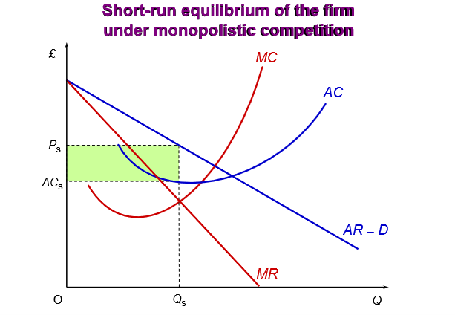

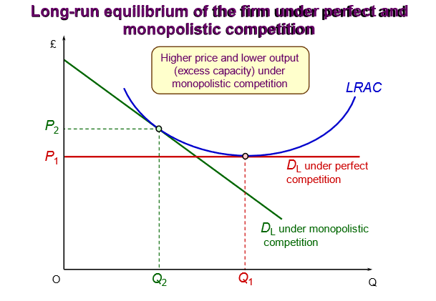

Benefits of monopolistic competition to restaurant goers: variety and choice - wide range of choices available due to product differentiation. Innovation and quality improvement – competition among restaurants drives innovation and a continuous attempt to improve their offerings , introduce new dishes and enhance service quality. Compeition pushes restaurants to maintain high standards. Pricing options – although restaurants operating under monopolistic competition have (the demand curve is likely to be highly elastic). some control over the price, the presence of alternatives keeps pricing competitive . The lack of long-run supernormal profits under monopolistic competition are likely to help keep prices down.
Drawbacks for consumers: higher prices due to differentiation – since restaurants compete on factors other than price they may charge more to cover the cost of these differentiating features. Restaurants are more limited in the economies of scale they can benefit from (compared to an oligopolist or monopolist). Less will be sold at a higher price than under perfect competition. Firms will not be producing at the least-cost point. Information overload – the abundance of choice can sometimes overwhelm customers.
(Total: 15 marks)

Question 2

Examine the role of research and development (R&D) as a source of a positive production externalities. Discuss how R&D can lead to broader societal benefits beyond the individual firm and evaluate the potential role of government intervention in promoting R&D activities.

Answer: Externalities are an example of a market failure. Externalities occur when the actions of consumers and producers directly involved in a transaction (the first and second parties) have an impact on other people not directly involved in the transaction (third parties). With production externalities, the marginal benefit/cost to society from the production of the good differs from the private cost marginal cost/benefit borne by firms. When we add the external benefits/costs of production (benefits are treated as negative costs) to the private costs, we get the social costs of production. Positive production externalities are positive spillover effects on other people of firms’ production activities. When there are external benefits of production, the marginal social cost is less than the marginal private cost.
One of the major objectives of government policy is to achieve social efficiency – production and consumption at the point where MSB = MSC. In this case it would be socially efficient to produce more.

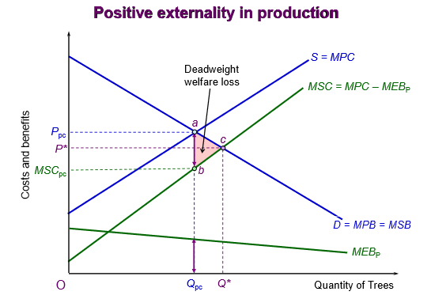

1. The government could use tax incentives to make R&D more cost effective, for e.g. tax breaks on research expenses. 2. It could directly fund R&D projects or encourage public-private partnerships in which government and firms co-invest in R&D. 3. The government could offer subsidies to firms to reduce the costs of R&D activities. 4. It could facilitate collaboration by promoting collaboration between academic institutions and businesses. 5. It could strengthen patent systems to protect intellectual property. 6. It could promote favourable regulatory requirements. 7. It could promote education and workforce development, so that firms have access to a highly skilled workforce and talented researchers. 8. Finally, it could provide a clear long-term vision and political stability.
(Total: 15 marks)

Question 3

- Discuss the relationship between marginal utility and consumer surplus in determining how much value consumers derive from a good or service. Using a real-world example, explain how the law of diminishing marginal utility affects consumer decision-making and the overall consumer surplus in a market.
(10 marks)
People buy goods and services because they get satisfaction from them. Economist’s call this satisfaction ‘utility’. Marginal utility is the additional satisfaction from consuming one extra unit within a given period of time. For e.g., we might refer to the marginal utility that Jude gains from her third cup of tea of the day or her eleventh cup. Up to a point, the more of a commodity you consume, the greater will be your total utility. However, as you become more satisfied, each extra unit you consume will probably give you less additional utility than previous units. At some level of consumption, your total utility will be at a maximum and marginal utility will be zero. It’s also possibly to feel displeasure from consuming an additional unit (negative marginal utility). The problem is that utility is subjective. One solution to that is to measure utility with money. Marginal utility becomes the maximum amount that a person would be willing to pay to obtain one more unit. If Phil is prepared to pay to pay 70p to obtain a second packet of crips, then that packet yields him 70p worth of utility.
Marginal consumer surplus is the difference between the maximum amount that you are willing to pay for one more unit of a good (i.e. your marginal utility) and what you are actually charged (i.e. the price).

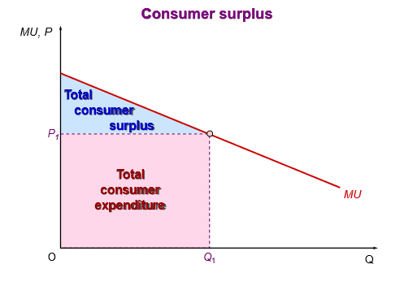

- How can changes in price or income influence this relationship and the distribution of consumer surplus?
(5 marks)
Changes in price – a decrease in the price of a good increases the consumer surplus, as the consumer can now purchase the good for less than they were originally willing to pay. On the other hand, a price increase reduces consumer suplrus.
Changes in income – when a consumer’s income increases, their willingness to pay for goods or services typically rises, as they can afford to spend more. A decrease in income reduces the consumer’s ability to pay, lowering consumer surplus. In this case, consumers may either purchase fewer units of a good or settle for cheaper alternatives, thereby decreasing the satisfaction they derive from their purchases. It’s also worth noting the diminsing marginal utility of income. The more you earn, the lower will be the utility from each extra $1. If people earning £15,000 a year earned an extra £1000, they would feel much better off; their marginal utility from that income would be relatively high. If people already earning £500,000 per year earned an extra £1000, however, their gain in utility will be less.
(Total: 15 marks)

Question 4

- Explain what a country’s balance of payment account records and provide a brief summary of the three main parts of a country’s balance of payments account.
(7 marks)
A country’s balance of payments account records all the flows of money between residents of that country and the rest of the world. Receipts of money from abroad are regarded as credits and outflows of money are regarded as debits. The current account records payments for imports and exports of goods and services, plus incomes flowing into and out of the country, plus net transfers of money into and out of the country. The capital account records the flow of funds into the country (credits) and out of the country (debits), associated with the acquisition or disposal of fixed assets, the transfer of funds by migrants, the payment of grants by the government for overseas projects, debt foregiveness by the government and the receipt of money for capital projects. The financial account records cross-border changes in the holding of shares, property, bank deposits and loans, government securities, etc. In other words, the financial account is concerned with the purchase and sales of assets (in comparison to the current account which is concerned with money incomes).
- The pound has fallen against the dollar in recent years. Using this example, or another of your own choosing, explain the major possible causes of a depreciation in the value of a currency.
(8 marks)
A shift in the demand and supply curves of the currency will cause the exchange rate to change. The following are possible causes of a depreciation: (i) a fall in domestic interest rates – UK rates would now be less competitive for savers and depositors. (ii) Higher rates of inflation in the domestic economy than abroad. UK exports will become less competitive and the demand for sterling will fall. At the same time, imports will become relatively cheaper for UK consumers and the supply of sterling will rise. (iii) A rise in domestic incomes relative to those abroad – if UK incomes rise, the demand for imports, and hence the supply of sterling, will rise. (iv) Relative investment prospects improving abroad – if investment prospects become brighter abroad than in the UK, perhaps because of better incentives abroad or worries about an impending recession in the UK, the demand for sterling will fall and the supply of sterling will rise. (v) Speculation that the exchange rate will fall – if businesses involved in importing and exporting, and also banks and other foreign exchange dealers, think that the exchange rate is about to fall, they will sell pounds now before the rate does fall. The supply of sterling will thus rise. (vi) Other country specific factors, such as Brexit, could be mentioned.
(Total: 15 marks)

Question 5

Using an AD/AS diagram, illustrate the objective of supply-side policy and then
provide examples of policies that can be used to achieve this objective.

The goal of supply-side policies is to shift the LRAS to the right, representing an increase in the economy’s potential output. This creates sustainable economic growth and better employment prospects.
In the diagram, assume initially that the economy is at equilibrium with output at Y_{P1} and the economy’s price level at P₁. Now assume that potential output rises from Y_{P1} to Y_{P2}, as result of supply-side policies. The short- and long-run AS curves move rightward – say to SRAS₂ and LRAS₂. The size of the shifts will reflect the increase in the economy’s productive capabilities. If the economy’s extra capacity is used, it has the effect of increasing the real national income of the country; people are now able to make more purchases. There may also be a rightward shift in the AD curve. If the extra real income generated by the increase in output generates an equivalent amount of additional real spending, the AD₁ curve will shift to AD₂. In such a case, actual output would increase by the same amount as potential output, i.e. Y_{P2} – Y_{P1}. If however, the rise in potential output did not translate into sufficient extra spending, the AD curve would not shift sufficiently enough to the right to give a new equilibrium at Y_{P2} and a negative ouput gap would emerge.
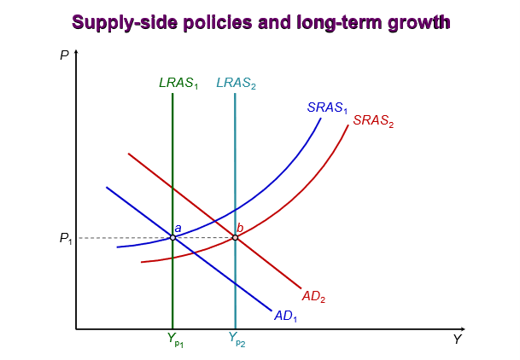

Students should discuss a variety of supply-side policies – both market-oriented and government-coordinated. The former involves reducing taxes and government involvement (e.g. privatisation, deregulation) to encourage entrepreneurial activity.
The latter is the reverse – with government increasing their spending on R&D, and technology, often seeking to identify sectors in which rapid growth is likely (or socially desirable).
(Total: 15 marks)

END OF SOLUTIONS

